**Create Node-RED Service**

| **Date** | **04-11-2022** |
| --- | --- |
| **Team ID** | **PNT2022TMID44069** |
| **Project Name** | **Smart Solution For Railways** |

Aim: To create a web application create a Node-RED service.

Steps followed:-

* Navigated to the App creation page

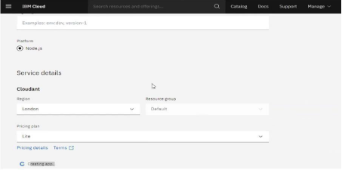

* Entered project details and clicked on create
* Clicking on the “Deploy your App” Button

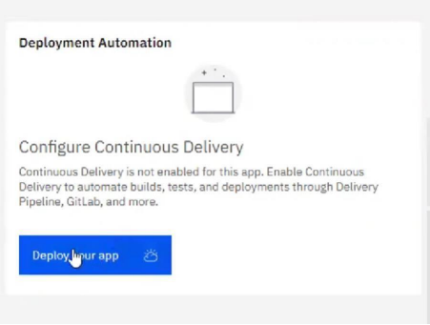

* Setting up the environment and deploying the app

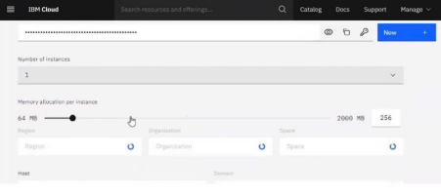

* Successfully deployed the app

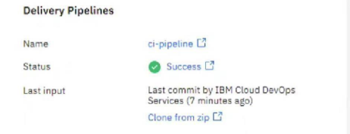

* Dragged and dropped components into the editor

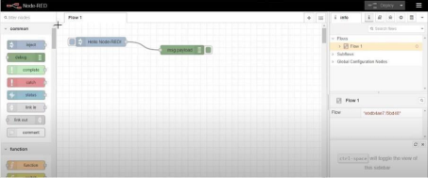

* Editing some values of the properties

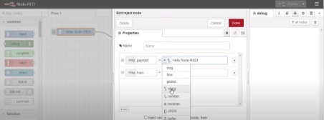

* Successfully deployed the app

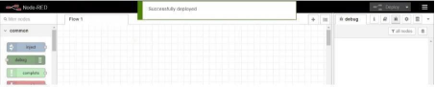

**Result: -Successfully created a NodeRED service on IBM Cloud**